Advanced assignment

## Introduction

**Welcome to our hackathon!** In this event, we challenge you to develop a program that can detect and recognize basic emojis in pictures. Emojis have become a universal language in digital communication, and the ability to accurately detect and interpret them in images is increasingly important.

Throughout this hackathon, you'll have the opportunity to showcase your programming skills and creativity by building a solution that can accurately identify and classify emojis in pictures. We're excited to see the innovative solutions you'll come up with, and we can't wait to witness the creative ways you'll tackle this emoji detection task. Good luck, and happy hacking!😊

## Challenge Instruction

Your challenge is to spot five types of emojis (happy, sad, crying, surprised, and angry) within a picture that's 800x600. These emojis can come in different sizes, colors, rotations, and may be a bit distorted. You might also find multiple emojis of each type in one picture. Before you start coding, take a look at the dataset to see what you're working with.

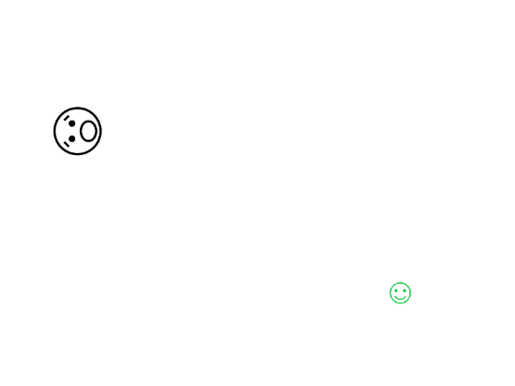

You will be provided more then 1000 pictures for training and validation. Subsequently, at the end of the day your algorithm will be automatically tested on 280 pictures with the same data distribution.

The output of the code will consist of the name of the picture, the name of each detected emoji, and the coordinates of the top-left corner of each detected emoji. This will allow for the identification of multiple emojis within a single picture.

Here's an example of the output format:

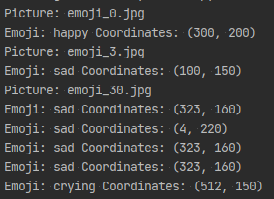

## Evaluation

* Up to 350 points are allocated for properly detecting emojis in pictures, with 1 point for each correctly classified emoji and 0.5 points for emojis that are properly classified but have coordinates off by 40 pixels or more. In case of missclassified emoji you lose 0.5 point.
* Additionally, up to 35 points are available for code quality.
* And up to 70 points for the originality of the solution to the problem.

## Advice:

* Starting with a basic solution and then iterating to improve it is a common and effective approach in problem-solving.
* Drawing the coordinates on the picture is also a helpful way to visually verify the results.
* Writing the first draft solution on paper can help in organizing thoughts and considering different approaches before implementing the code. It allows for brainstorming and refining the solution before diving into the coding process.